National Graduate Development Programme – Diversity update

**Purpose**

For information and decision

**Summary**

This report updates members on the national graduate development programme, and in particular the work that has been undertaken to widen participation in the scheme.

|  |
| --- |
| **Recommendation**  Board Members are invited to consider the contents of the report and provide comments or recommendations about the activity undertaken to widen participation on ngdp.  **Action**  Officers to progress this work in light of the Board’s comments. |

|  |  |
| --- | --- |
| **Lead Member:** | Cllr Judi Billing MBE |
| **Contact officer:** | Helen Jenkins |
| **Position:** | Principal Adviser - Leadership |
| **Phone no:** | 0207 664 3068 |
| **Email:** | Helen.jenkins@local.gov.uk |

**National graduate development programme (ngdp) update**

**Background**

1. The ngdp is the LGA’s flagship management trainee programme. It offers local authorities a unique opportunity to grow their own local government managerial leaders. Every year since 1999, ngdp has provided the sector with high quality graduates who are ready to work on strategic projects which contribute to the delivery of corporate goals of individual authorities.
2. The ngdp is a 2 year programme, where graduates are employed by local authorities and undertake a minimum of three placements. Alongside their employment, the LGA has commissioned the Solace Group to deliver a complementary learning and development offer. At the end of their two year programme the graduates will have developed a range of skills across of a variety of services. The ngdp acts as an opportunity for talented graduates to fast track their local government career and gives authorities the opportunity to nurture and develop their own talent.
3. At the last meeting of the Improvement and Innovation Board, Members requested information on the diversity statistics for the ngdp and this is provided within the report along with an update on the work that is underway to widen participation.

**Commitment to Diversity**

1. Each year the ngdp attracts thousands of applicants (4482 applicants in January 2019). The ngdp is a generalist management trainee scheme and therefore accepts applicants from across all disciplines as long as they meet the entry criteria (2:2 degree and eligibility to work in the UK). The ngdp is proud of its commitment to diversity. It is pivotal that local councils represent the diverse communities that they serve, in order to ensure effective developments and positive social change within their local areas. In recent years, the Leadership & Localism Team have undertaken work to ensure that participation in ngdp is as diverse as the communities that local government serves. This report will outline that commitment and the practical work that has been undertaken.
2. Every year the ngdp collects information at application stage from candidates to monitor diversity. The graphs in this report show the breakdown of the following protected characteristics: gender, sexual orientation, age, disability and ethnicity. Commentary below each graph is provided on particular points to note and the latter part of the report provides information about the work that is being undertaken to broaden the diversity of ngdp and ensure that it is an inclusive programme. It should be noted that the figures relate to candidates who have reached stage 4 of the process (successfully passed assessment centre). C18, C19, C20 refers to the cohort number and year (e.g. cohort 18 finished in 2018).

Points to note: In recent years gender diversity on ngdp has been relatively balanced. Cohort 19 shows a bigger majority of women candidates progressing to council interview stage.

Points to note: the number of candidates choosing not to declare their sexual orientation is higher than other categories (see paragraph 11 point iii).

Points to note: Candidates with a 2:2 degree are eligible to apply for ngdp irrespective of when they graduated. However, the vast majority of graduates are within the 20 – 24 category (see paragraph 12).

Points to note: while no candidates declared a disability on their application form for C20, a number of candidates have subsequently disclosed a disability once appointed (see paragraph 11 point iii).

Points to note: the ethnic breakdown of candidates is roughly equivalent to the 2011 census data (86% white, 7.5% Asian, 3.3% black, 2.2% mixed, 1% other). However, it should be taken into consideration that these census figures are not directly representative of the councils currently participating in ngdp (which for cohort 20 included 23 London councils).

**Widening participation**

6. The following activity has been undertaken by the ngdp team to work towards increasing participation from diverse groups and to provide assurance that the current approach and processes are robust.

**Marketing of the programme to candidates**

1. A variety of methods are used to attract a broad range of graduates. This includes
   1. participation in the Times Top 100 and Guardian 300 publications
   2. advertising on Target Jobs as a graduate employer: including publishing a specific diversity statement (see below):

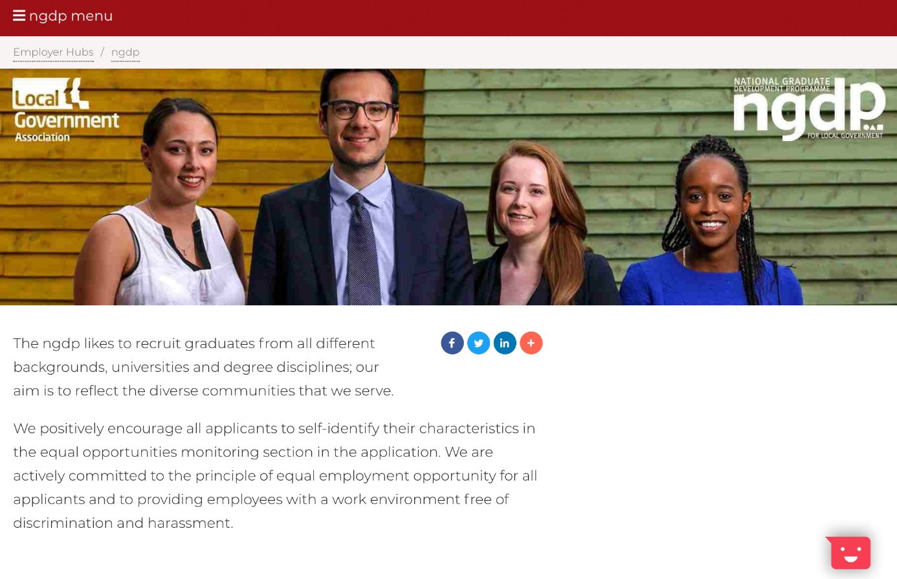

* 1. social media: including case studies or “stories” to tell the real-life experiences of graduates on ngdp from all backgrounds
  2. university careers fairs
  3. public sector panel events.

8. By using a varied approach to marketing, it is anticipated that candidates will be attracted via different routes and from different backgrounds. It is a requirement that any social media, publications or other photographic or video campaigns feature a mix of graduates from diverse backgrounds.

9. In 2018 the ngdp team commissioned a piece of research by HESA (Higher Education Statistics Agency) that provided a breakdown of university graduates in the UK for the last 10 years by gender, age, disability and ethnicity. This information was then used to help target which universities to visit during the 2018 career fair season.

**Specific diversity events**

10. During 2018, the ngdp have piloted new events aimed specifically at increasing participation in the programme from diverse groups. This has included:

10.1. Diversity coffee morning events at Coventry University and London Met University.

10.2. Planned support to Blind in Business events to help prepare graduates with visual impairments for interviews/assessment centre

**Recruitment**

1. The ngdp includes a thorough five stage application process which is designed to be robust and reduce the risk of adverse impact by providing a rounded view of candidates’ abilities across a range of tests and assessments. The stages are outlined below:
   1. **Application form:** from 2018 the application form included a wider range of diversity monitoring questions that ranged from protected characteristics to social mobility. This information is not yet available for analysis but the questions are included at Annex A.
   2. **Online tests:** four online tests that were specifically updated for 2018 to be more accessible.
   3. **Diversity statement:** a diversity statement has been included in all our application communications which encourages all applications to positively self-identity their characteristics in the equalities monitoring section of the form. This is particularly to address the non-disclosure of certain characteristics (e.g. disability and sexual orientation) shown in the graphs.
   4. **Situation Judgement Questionnaire:** A series of scenario based questions that have been designed based on ngdp case studies. SJQs are considered to be less likely to cause an adverse impact compared to other more traditional methods
   5. **Video interviewing:** marking of the video interviews is undertaken by an external provider who view the interviews “blind” as to minimise the potential for bias.
   6. **Assessment centres:** all assessors undertake an e-Learning module which covers unconscious bias. Each day moderation is undertaken to quality check the evidence that assessor record against scores for candidates to ensure that they are consistent and unbiased.
   7. **Candidate travel:** a contribution is paid to candidate travel expenses
   8. **Disability**: scribes, extra time or specialist equipment can all be provided for candidates with disabilities who attend an ngdp assessment centre.
   9. Assessors are chosen to ensure a diverse and representative group of people, as these will often be the first people that the candidates meet when applying for ngdp.
   10. **Local recruitment:** bespoke workshops have been designed to support councils undertake local recruitment events to attract residents to apply for the programme. This is particularly helpful for councils who have targets around local recruitment and in diverse areas.
   11. Entry criteria has also been reduced for the last 2 cohorts to 2:2 (rather than 2:1) to increase participation from a social mobility perspective.

**Looking to the future**

1. The ngdp is growing and widening participation in terms of candidates and the councils that participate remains a priority for the programme. Planned activity for 2019 includes:
   1. Identifying partners to work with on specific diversity initiatives (e.g. promoting ngdp to underrepresented groups via existing networks)
   2. Producing and publicising short videos and case studies from current and past ngdp trainees that talk frankly about diversity (including disability, ethnicity and sexual orientation).
   3. Promotion of ngdp to existing council employees and mature graduates who are considering a career change. The ngdp does not have an age limit, however, the statistics show that it is heavily weighted to people who have graduated within the last few years. Over the last few cohorts there have been a small number of graduates who have had careers in other sectors or disciplines before choosing ngdp and promoting these stories could provide a positive narrative to help widen participation.
   4. Investigating the possibility of an external evaluation of approach to widening participation and support producing a focussed diversity strategy.

**Financial implications**

1. All programmes will be met from existing budgets.

**Implications for Wales**

1. There are no implications for Wales.